**Step 1: Download the dataset and disable autodetect relationships in Power BI.**

1. Download the **Adventure Works Data.xlsx** workbook from the exercise page on the Coursera platform.

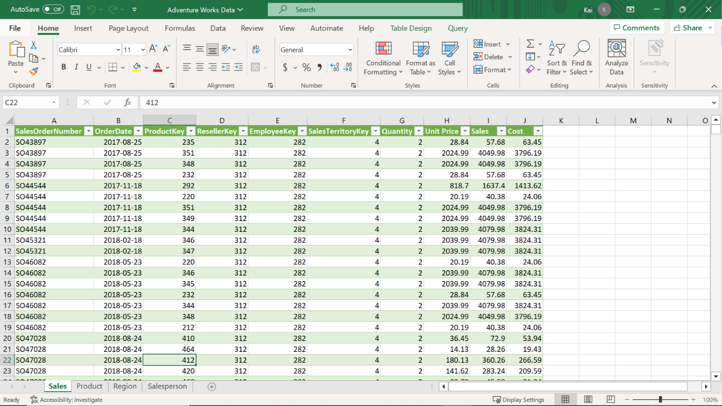

1. To disable autodetect functionality, select **File**, then **Options** and **Settings**, and select **Options**. This opens the **Options** dialog box.
2. On the left bar of the dialog box, select **Data Load** and then deselect **Autodetect new relationships** after the data is loaded. Then select **OK**.

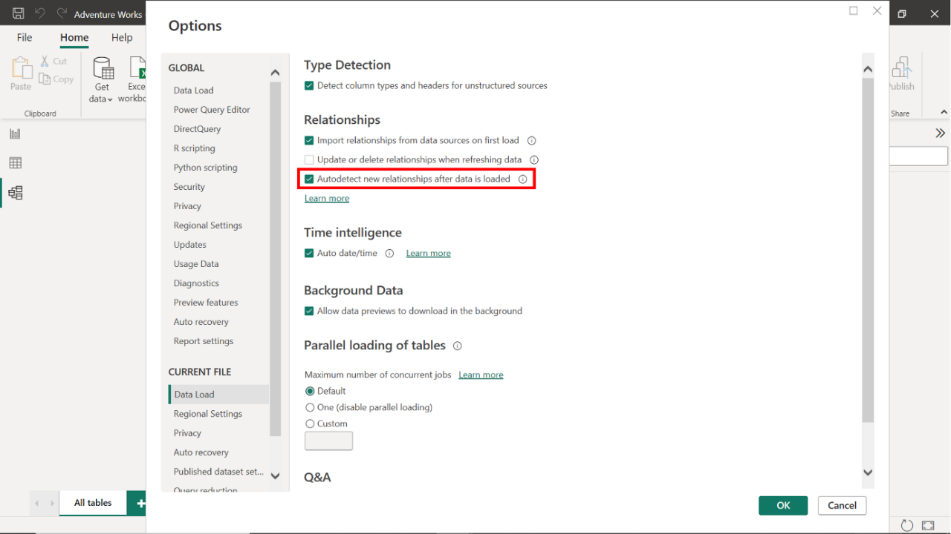

**Step 2: Load the data from the Excel workbook.**

1. Launch Power BI desktop and create a new project. To create a new project, select the **File** menu, then select **New**.
2. Import the Adventure Works dataset that you have downloaded. In the **Home** tab, select the **Get Data** drop-down menu. Then select an appropriate data source.
3. For the current exercise, select **Excel Workbook** and navigate to the folder containing the Adventure Works dataset.

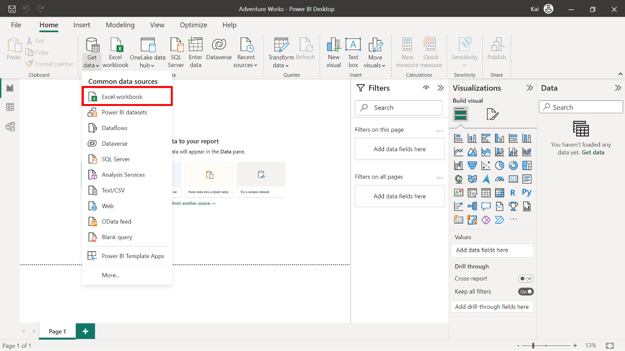

1. Once you select and load the data, Power BI opens a **Navigator** dialog box that enlists all the tables available to load in the Excel file and the data preview on the right side of the **Navigator**.
2. Select the **Sales**, **Product**, **Region**, and **Salesperson** tables, then select **Load**.

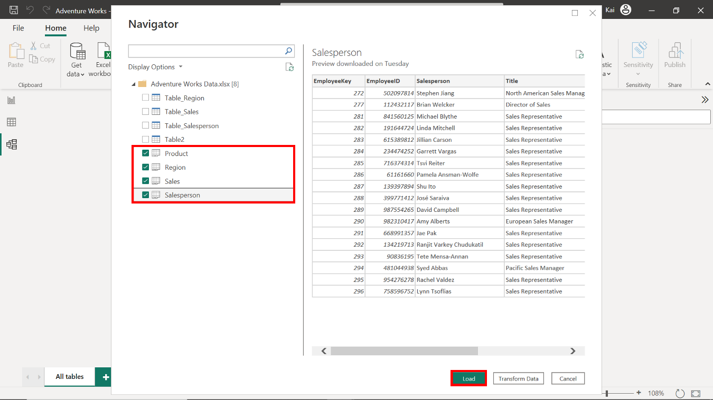

1. You can view the loaded dataset on Power BI desktop by selecting the **Data view** option from the left sidebar of the interface.

**Step 3: Configure a Star schema.**

1. A unique identifier is usually an ID column or key column within the data table. Once you select a column, Power BI displays the total number of rows at the bottom left corner of the interface with unique values. For the ID column, the number of rows and unique values should be the same.
2. In the Adventure Works dataset, the **Sales** table is the fact table that records transactional details.

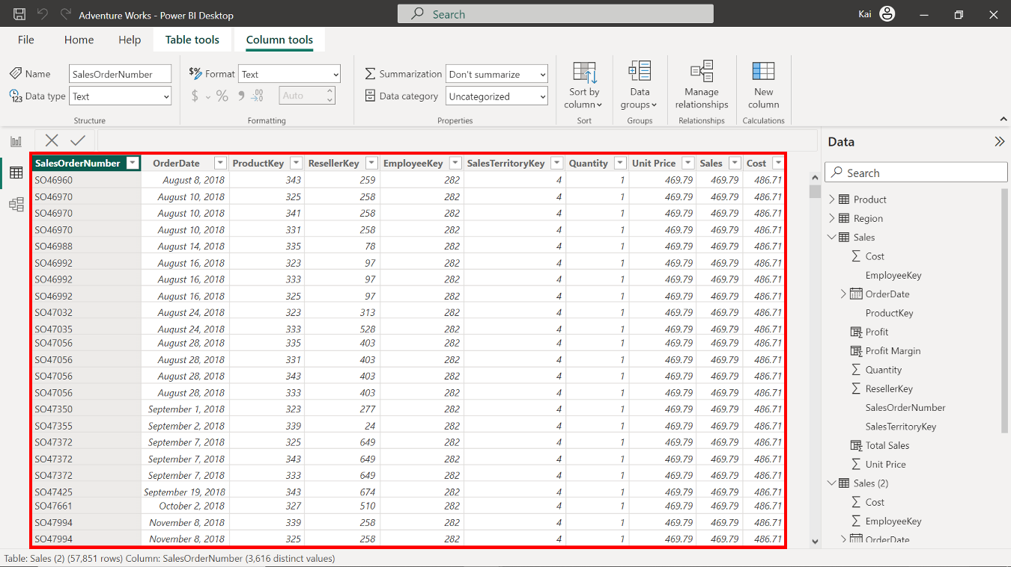

1. The **Products**, **Region**, and **Salesperson** tables are the dimension tables. To determine the unique identifier, check the total number of rows at the bottom left corner of the interface with unique values.

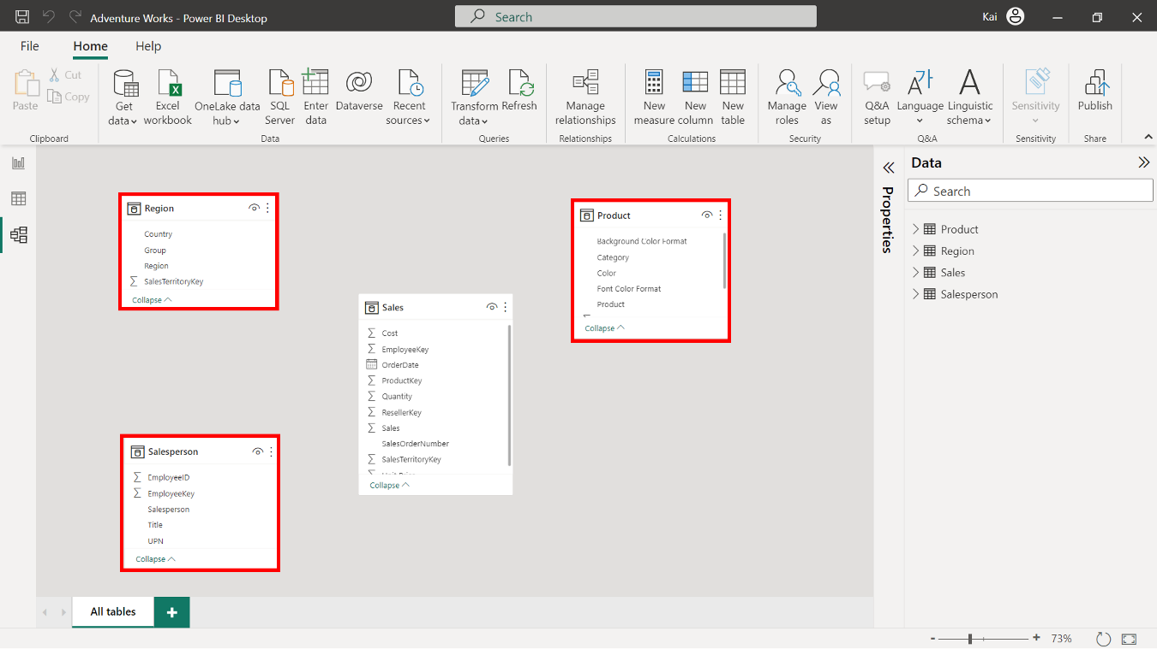

1. To create the schema and the model relationships between the fact table and the dimension tables, select **Model view** on the left sidebar of Power BI desktop.
2. You must establish relationships between the fact and dimension tables in the **Model view**. Select and drag the foreign key fields from the fact table to their corresponding primary key fields in the dimension tables.
3. Connect **Sales.ProductKey** to **Products.ProductKey**, then **Sales.SalesTerritoryKey** to **Region.SalesTerritoryKey**, and finally, **Sales.EmployeeKey** to **Salesperson.EmployeeKey**.
4. Alternatively, you can build relationships using the **Create Relationship** dialog box. Access the dialog box by selecting **Manage Relationship** in the **Model view** of Power BI desktop.

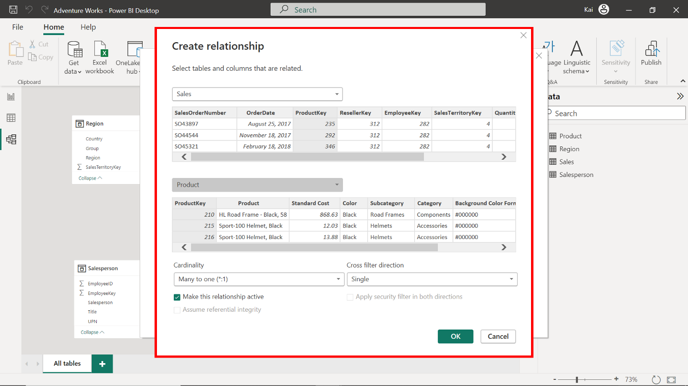

1. Once the relationships are established, double-check to ensure each type is a many-to-one relationship. Select the **connector line** between the tables to open the **Edit Relationship** dialog box. Here you can verify that the cardinality is set to **Many-to-One** and that the cross-filter direction is set to **Single**.

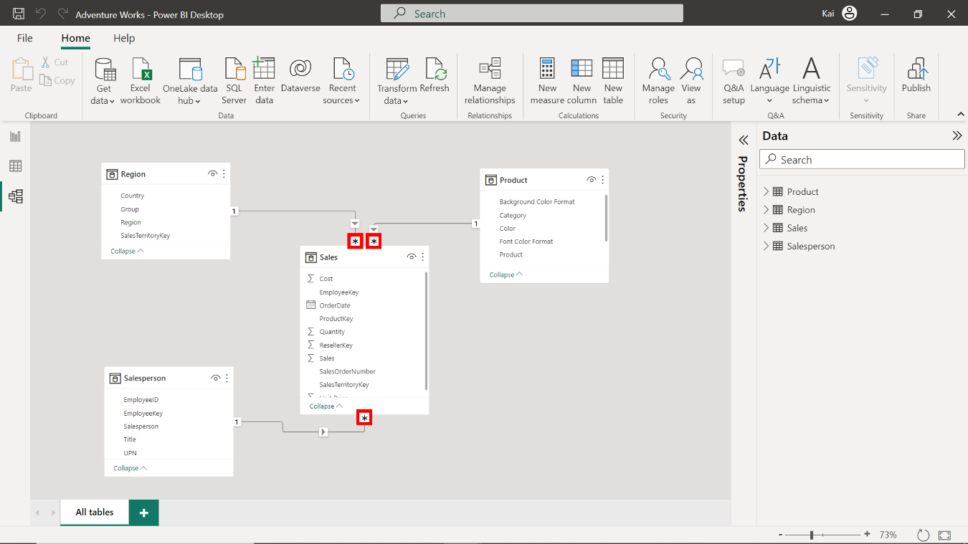

**Step 4: Save the Power BI project.**

1. To save the project, open the **File** menu, select **Save As** and provide an appropriate name for the project along with a path to the folder on your local machine.

**Conclusion**

Upon completing these steps, you will have successfully configured a Star schema for the Adventure Works dataset, allowing for easier analysis and reporting of the sales data.